Types of Weathering Around
- Biological weathering

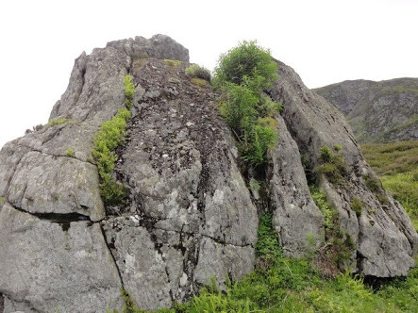
Biological weathering usually happens if plants, living organisms get into a rock’s spaces, and grow or do activities that makes it crack. The picture shows a plant grown between rocks with cracks on the rocks. These plants got between rocks by means of dispersion mechanisms. Their roots embedded between the rocks and as they grow bigger, the roots caused the rocks to expand thus cracking and splitting off of some parts of the rock.
- Chemical weathering

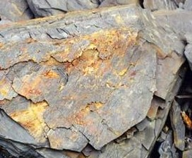
The picture represents a chemically weathered stone. Chemical weathering is common in areas with active industrial activities that emit carbon, nitrogen and other green gases. The gases diffuse in to the atmosphere; combine with water vapor in the atmosphere to form acidic water. When it rains, the water reacts with components of the rock making the rock to crack, split or corrode. Continuous corrosion of a rock may lead to widespread breakage of rock and deposition of its components in the neighboring ground.
- Physical weathering
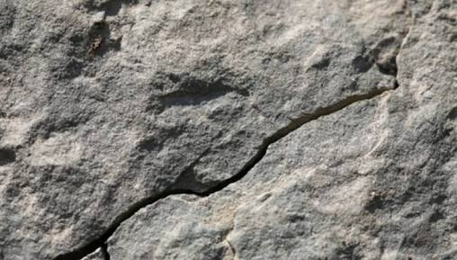
The above picture portrays a physical weathering of a rock. The weathering process resulted into fragmentation of the rock which depends on thermal properties of the rock. Generally, when there is a temperature increase, rocks tend to expand and vice versa. Expansion and contraction of rocks occur during the day and night respectively and the continuous process causes the rock to crack. When water gets into the crack, at low temperatures, it will freeze and expand causing the rock to crack further and separate.

